DIVAS

An Experiment with Investing in Dividend Aristocrats

South Bay Bogleheads
June 10, 2019

Jim Cosgrove

This presentation is for informational, entertainment, and discussion purposes only. It’s not investment advice. It’s not a pitch to buy anything or for me to be your advisor. I don’t own any of the stocks mentioned. I’m a subscriber to FastGraphs. The calculations, observations, and opinions are mine and I can change my mind about any of it whenever.

The Portfolio Set-up

- $200,000 to invest. (This is an arbitrary amount.)

- 50% to Selected Dividend Aristocrats.
https://en.wikipedia.org/wiki/S%26P_500_Dividend_Aristocrats

- 50% to ProShares S&P500 Dividend Aristocrats ETF: NOBL
https://www.proshares.com/dividend_growers/

Finding the Right Aristocrats

- Use the current list of Dividend Aristocrats.
https://en.wikipedia.org/wiki/S%26P_500_Dividend_Aristocrats

- Use FAST Graphs for current and historic data.

https://www.fastgraphs.com/about-us/

The Finalist Criteria

- Be a Dividend Aristocrat.

- Have a PE ratio comparable to prior low PE ratios within the last 20 years.

- Have a yield greater than the current 10-year US Treasury yield. (2.1%).

- Have a yield is comparable to its own prior high yields over the last 20 years.

Who’s Made the Cut?

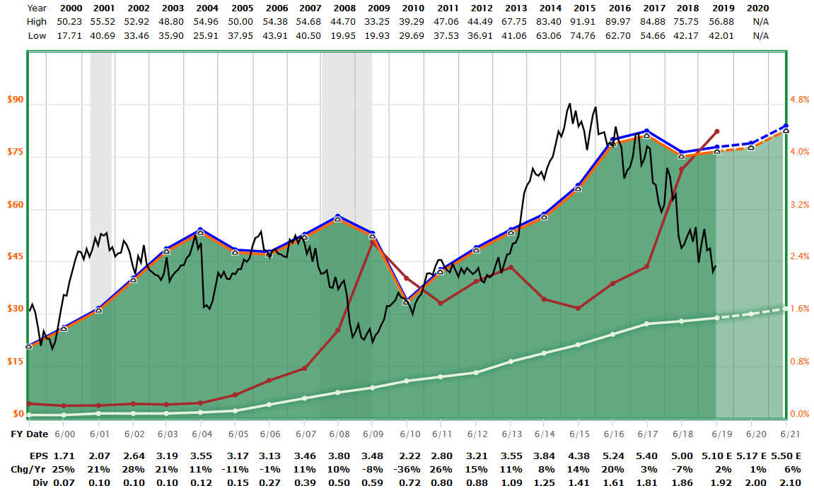

Cardinal Health CAH: PE = 8.6 Yield = 4.4%
Bought 7-2-18 @ $49.14. Currently $43.85.

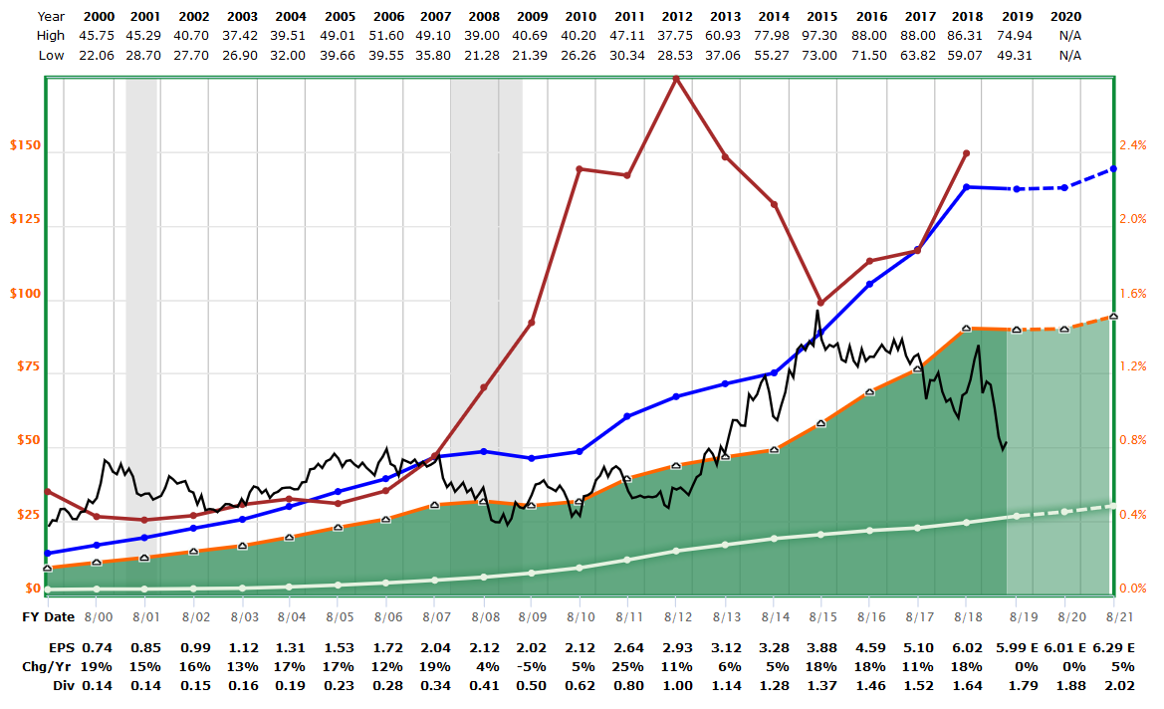

Walgreens WBA PE = 8.7 Yield = 3.4%
Bought 7-2-18 @ $60.39. Currently $51.97.

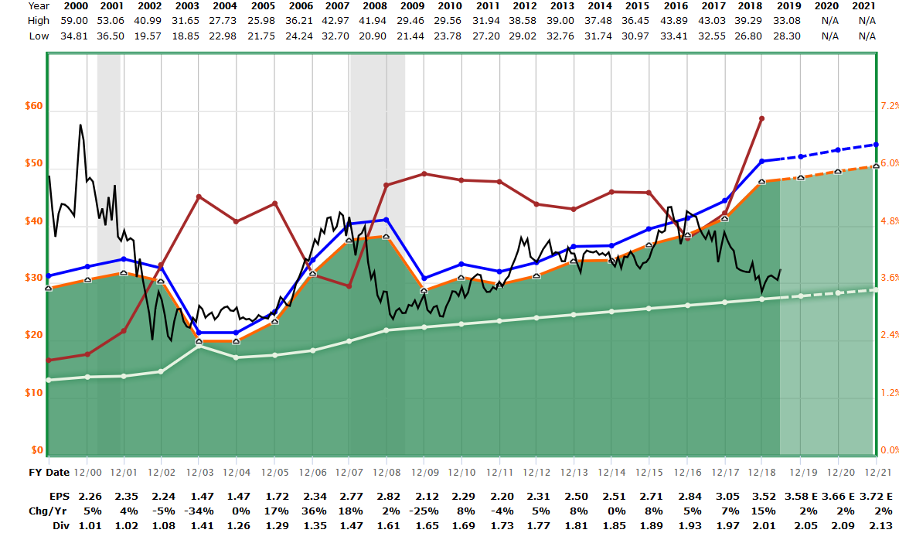

AT&T T PE = 9.2 Yield = 6.3%
Bought 10-27-18 @ $29.40. Currently $32.49.

None of the other 54 DIVAS Qualified!

DIVAS 1st Year Outcomes

Beginning Value @ May 24, 2018 $ 200,000

Change in Capital Value $ 681
CAH $1,443-
WBA 1,835-
T 331
NOBL 3,628

Dividend Income $ 3,086
DIVAS $ 679
NOBL 2,407

Interest on Cash $ 1,732

Ending Value @ May 31, 2019 $ 205,499 or about +2.8%.

DIVAS Year 1 Positions
As of 5-31-2019

NOBL $ 103,622
CAH 8,582
WBA 8,190
T 10,397
Cash 74,708

Total $ 205,499

NOBL vs VOO

Q: Is investing in dividend stocks worth it?

NOBL VOO

Style Large Cap Value Large Cap Blend
# of Issues 57 508
Assets $4.6 billion $112 billion
Yield 2.2% 2.1%
Expense ratio .35% .03%
5-Year pre-tax 9.6% 9.6%
5-Year after-tax 9.0% 9.0%

Several dozen other funds and ETFs are in the dividend space, including…

Vanguard Dividend Appreciation VIG
iShares Select Dividend DVY
Wisdom Tree US Large Cap Dividend DLN
Vanguard Dividend Growth VDIGX Closed to new investors.

Data from Morningstar and company websites.

A: Not in this particular 5-year term.

NOBL vs VOO
12 months ending 5-31-2019

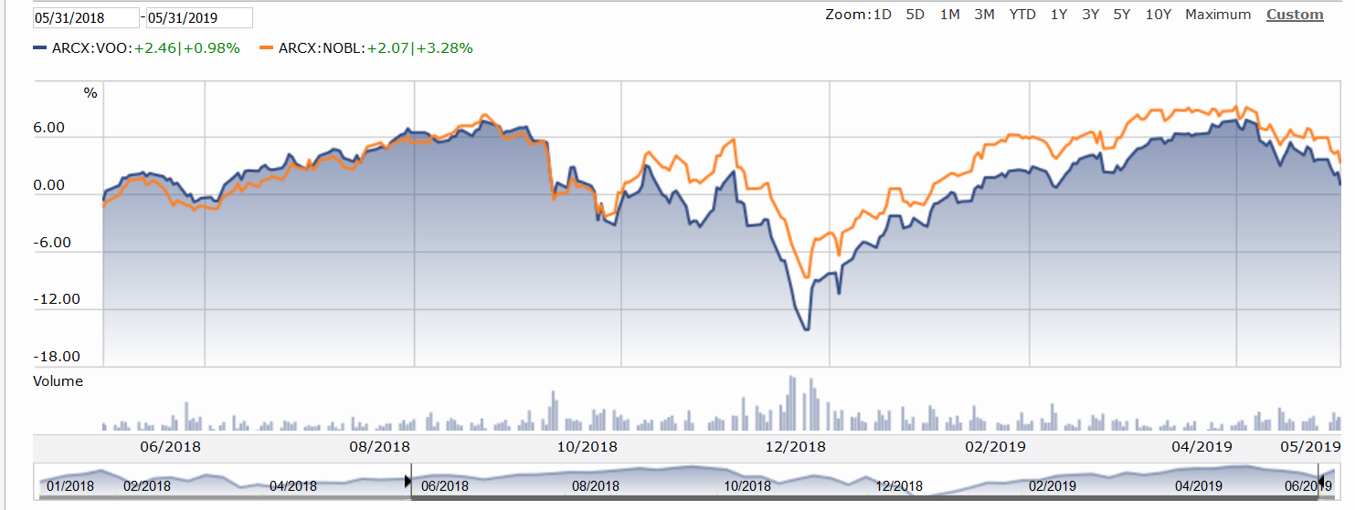

VOO in blue.
NOBL in red.

NOBL earned its apparent advantage during the two-week period from Nov 7-23, 2018.
See the next chart where the start date is moved to November 23rd.

NOBL vs VOO
From Nov 23, 2018 to 5-31-2019
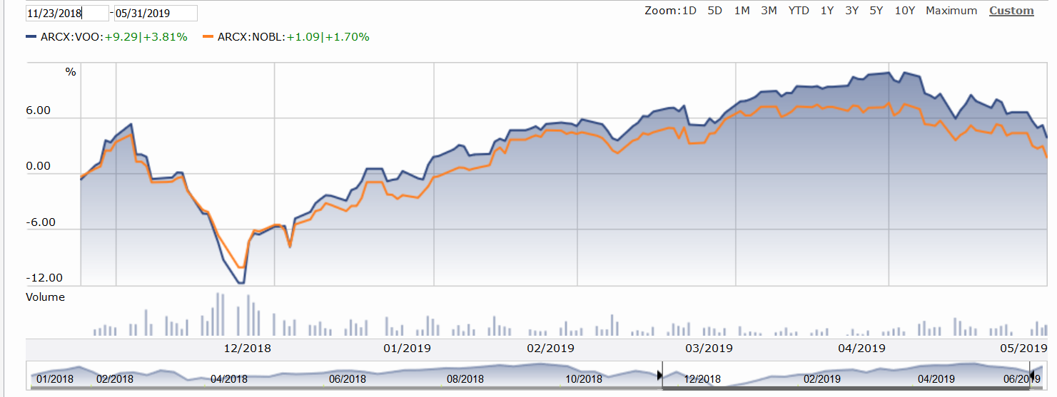

VOO in blue.
NOBL in red.

Observations:
1- The calendar period under review matters greatly.
2- Dividend paying stocks are defensive in nature. They may go down less in a downturn, but will likely lag a bit during a bull cycle. Keep in mind that markets are in bull cycles more often than not.

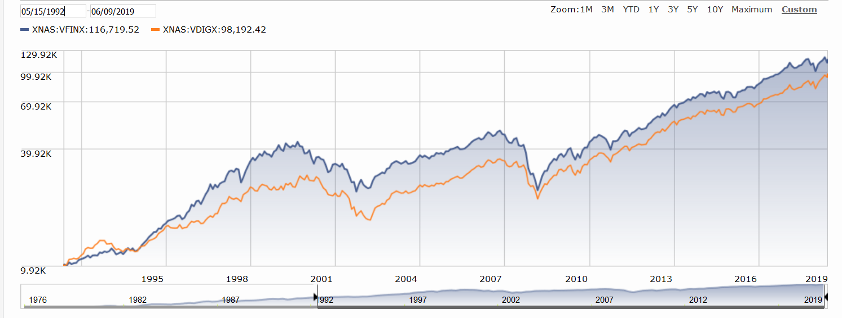

S&P500 in blue.
VDIGX in red.

Observation: The apparent lagging of the dividend-focused fund (VDIGX) is totally attributable to the dot com phenomena of the late ‘90’s. Ex that, the difference between the two funds is negligible. See the next chart.

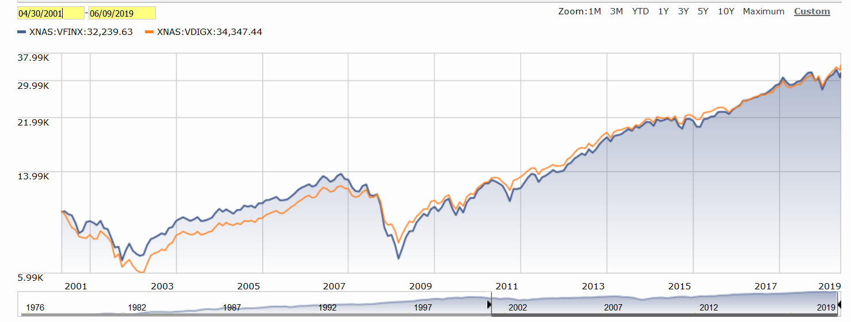

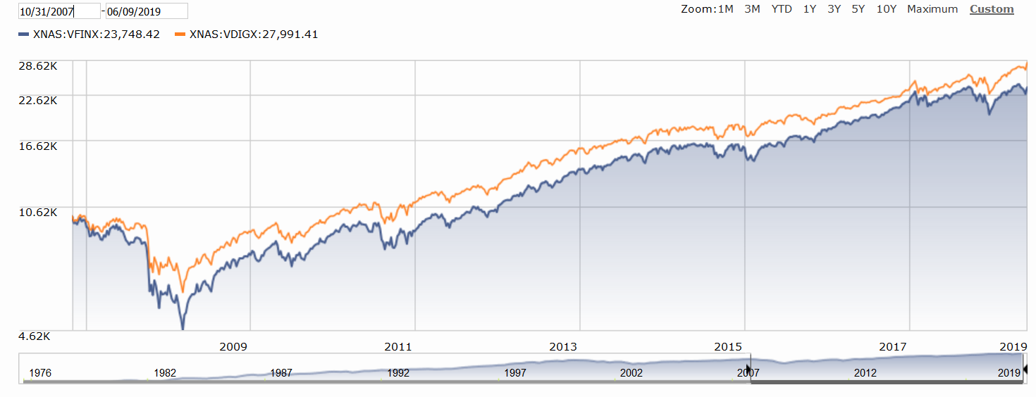
During the Great Financial Collapse, dividend-focused stocks somewhat muted the decline. After the low, they matched the advance. An investor would have needed to be on board for the whole period to take advantage of the dividend buffer.

What’s Next?

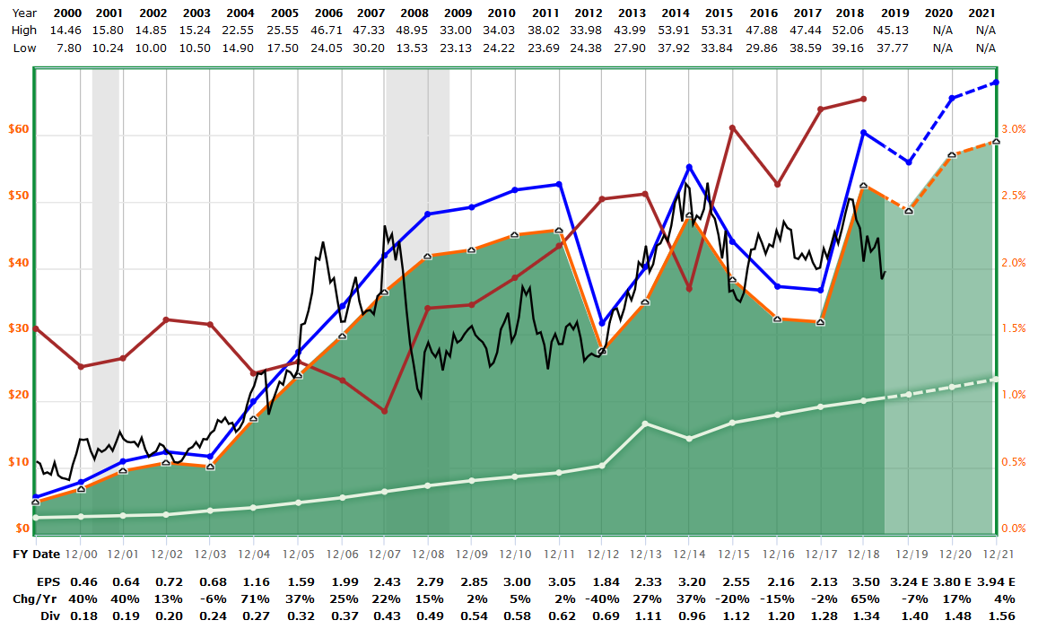

Archer Daniels Midland- ADM
Yield OK.
PE= 11. Need to see 8.

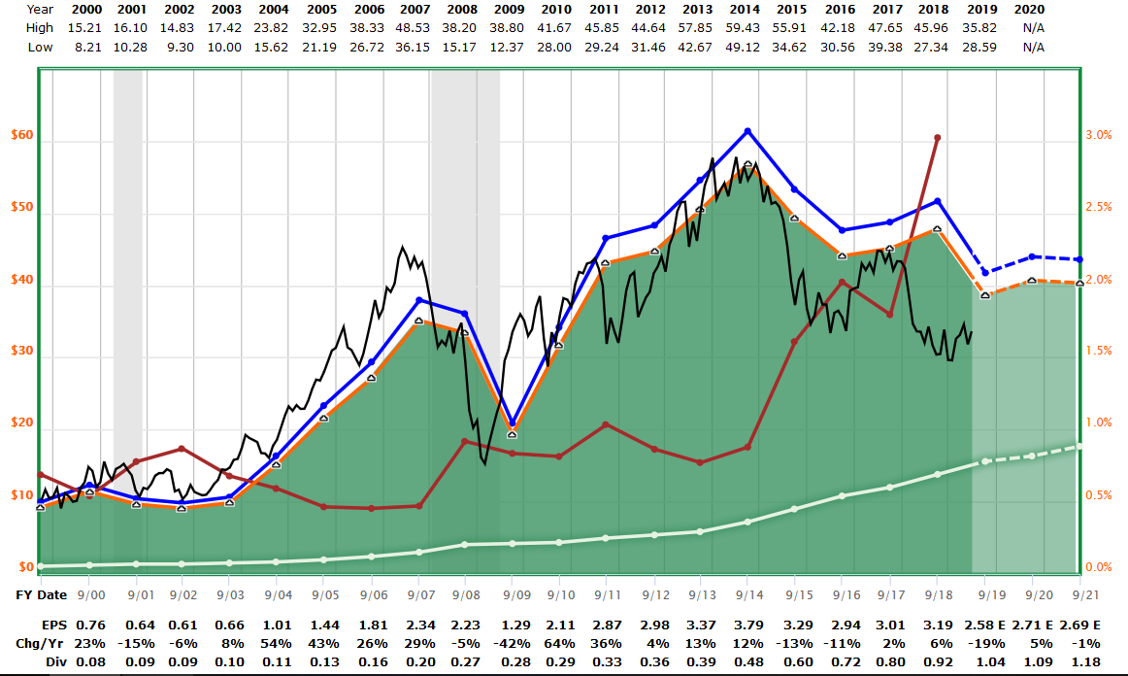

Franklin Templeton- BEN
Yield OK.
PE = 12. Looking for 8.

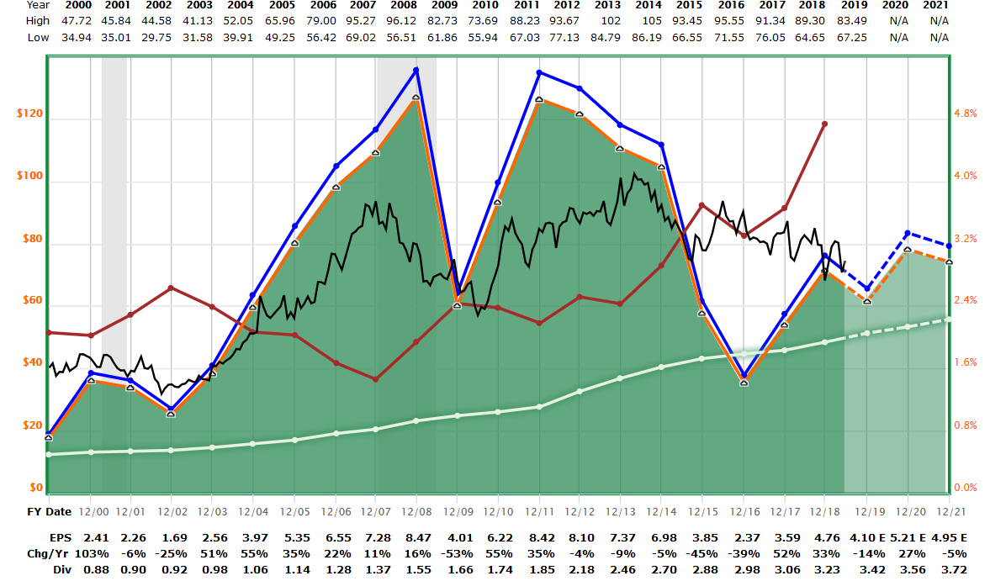

Exxon Mobil- XOM
Yield OK.
PE = 17. Something around 11 would be attractive.

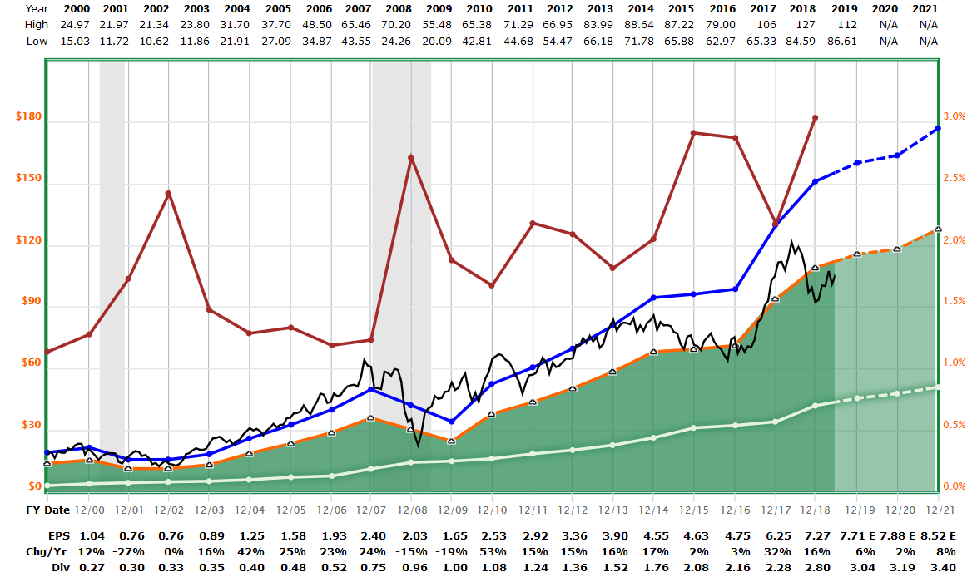
T Rowe Price- TROW
Yield OK.
PE = 14. Buy at 11 or better.

